Correlation

Correlation: A correlation is a linear relationship between two variables. Correlation measures the linear association between two variables.
Example:
- Is there any relationship between height and shoe size
- Number of cigarettes smoked per day and lung cancer.
- Supply and demand.

Scatter diagram: The basic idea of correlation analysis is to report the association between two variables. A Scatter Diagram is a chart that portrays the relationship between two variables.

X | 2 | 4 | 6 | 8 | 10 | 12
Y | 5 | 10 | 8 | 12 | 11 | 14

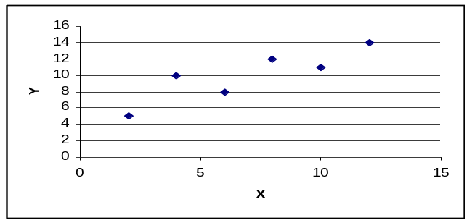
Fig: Scatter plot

Coefficient of correlation: The Coefficient of Correlation (r) is a measure of the strength of the linear relationship between two variables.
- Karl Pearson’s coefficient of correlation:
We calculate the Karl Pearson’s coefficient of correlation from the following formula:
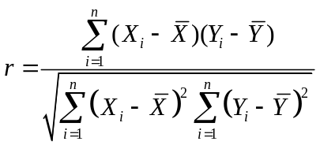

Properties of Correlation coefficient:

- A correlation coefficient varies from -1 to +1
- -1 indicating a perfect negative relationship (one increase while other decrease),
- 0 indicating no relationship
- +1 indicating a perfect positive relationship.
- The size of the correlation indicates the strength of the relationship; for example, the correlation coefficient -0.89 indicates a stronger relationship than a coefficient of +0.60.
- The closer to 1, the stronger the positive linear relationship
- The closer to 0, the weaker any positive linear relationship

Correlation Coefficient Interpretation:

Coefficient  Range | Strength of  Relationship
0.00 - 0.20 | Very Low
0.21 - 0.40 | Low
0.41- 0.60 | Moderate
0.60 - 0.80 | High Moderate
0.81- 1.00 | Very High

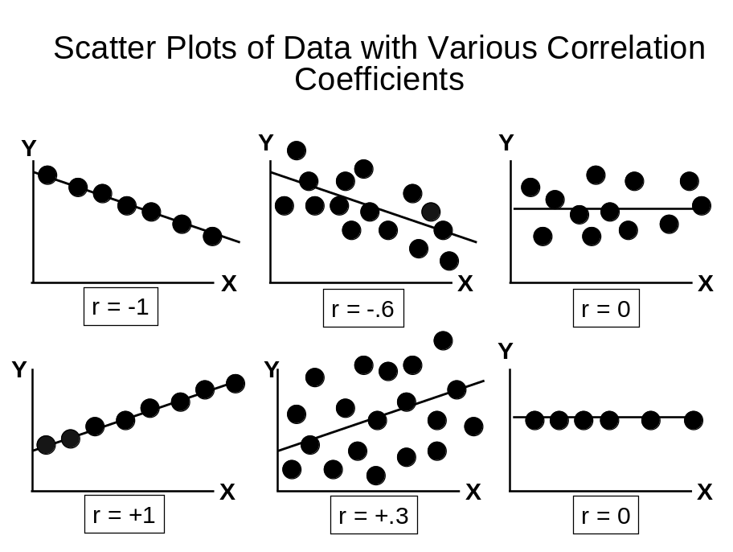

Problem: Mr. Johnson is concerned about the cost to students of textbooks. He believes there is a relationship between the number of pages in the text and the selling price of the book. To provide insight into the problem he selects a sample of eight textbooks currently on sale in the bookstore. Compute the correlation coefficient.

Book | Page(x) | Price($)(y)
Introduction to History | 500 | 84
Basic Algebra | 700 | 75
Business Management | 800 | 99
Introduction to Sociology | 600 | 72

a)Draw Scatter diagram
b) Determine the coefficient of correlation
c) Interpret the result.
Solution:
a) Scatter diagram:

a) 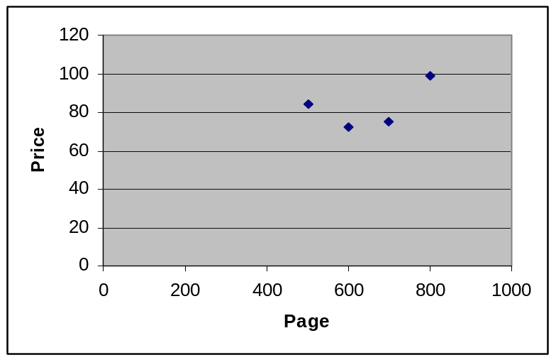

b) Here,
We know
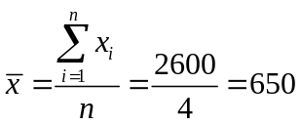
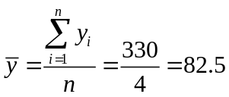

x | y | 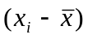 | 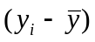 | 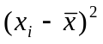 | 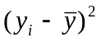 | 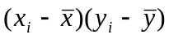
500 | 84 | -150 | 1.5 | 22500 | 2.25 | -225
700 | 75 | 50 | -7.5 | 2500 | 56.25 | -375
800 | 99 | 150 | 16.5 | 22500 | 272.25 | 2475
600 | 72 | -50 | -10.5 | 2500 | 110.25 | 525
 |  |  |  | 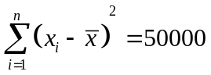 | 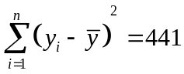 | 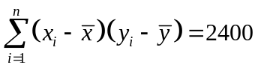

Now,
From the correlation coefficient
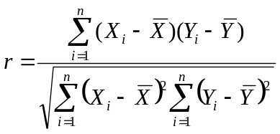
= 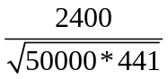

= 0.511
c) Interpretation: The correlation between the number of pages and the selling price of
the book is 0.511. This indicates a moderate association between the variable.

